Create a sample dataset and implement the below Pig commands on the same dataset.

1. Concat

The CONCAT() function of Pig Latin is used to concatenate two or more expressions of the same type.

Syntax

grunt> CONCAT (expression, expression, [...expression])

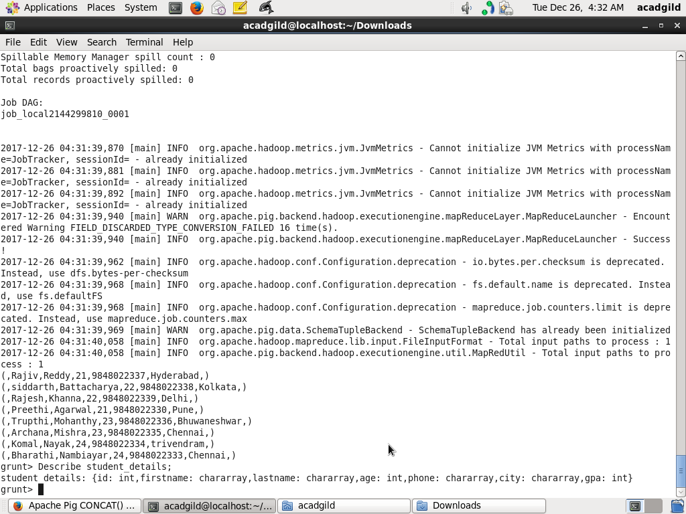

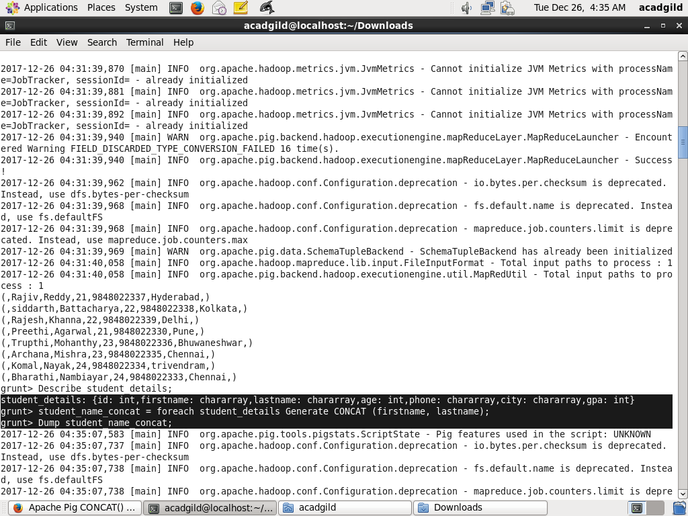

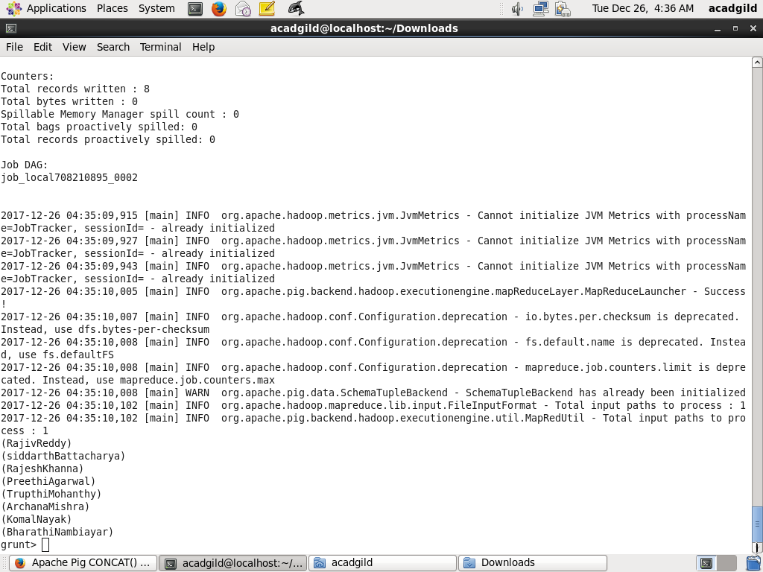

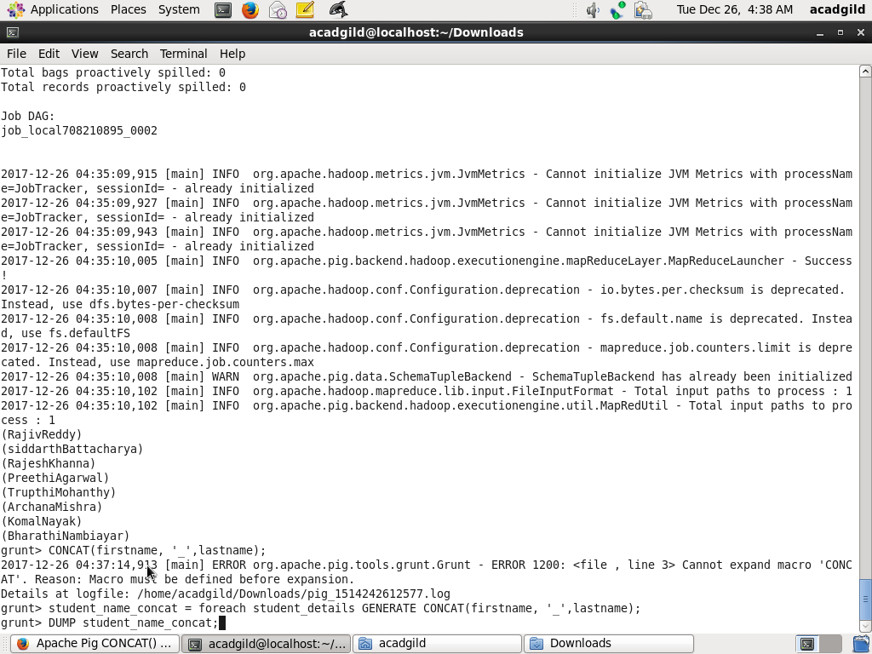

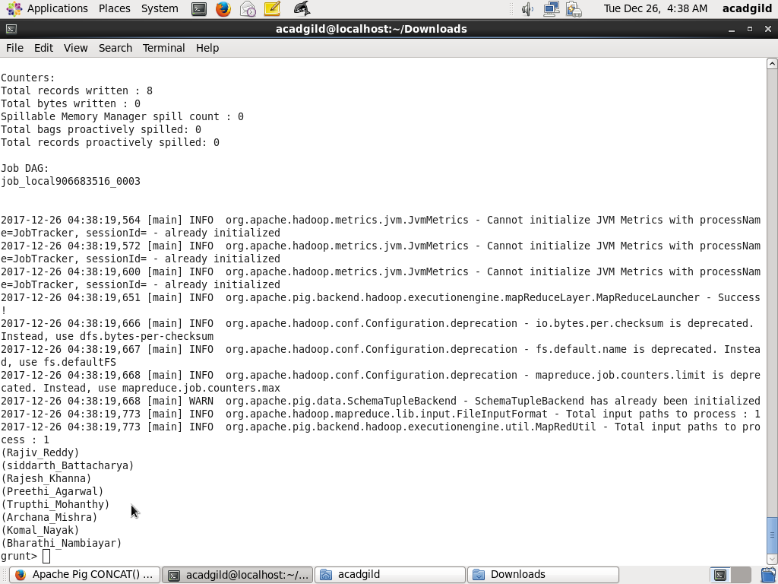

1. **Tokenize**

The **TOKENIZE()** function of Pig Latin is used to split a string (which contains a group of words) in a single tuple and returns a bag which contains the output of the split operation.

## Syntax

Given below is the syntax of the **TOKENIZE()** function.

grunt> TOKENIZE(expression [, 'field_delimiter'])

As a delimeter to the **TOKENIZE()** function, we can pass space [ ], double quote [" "], coma [ , ], parenthesis [ () ], star [ * ].

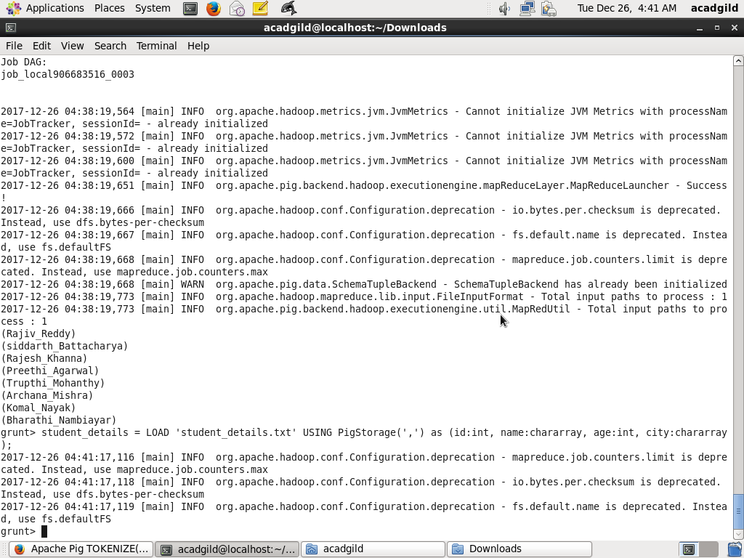

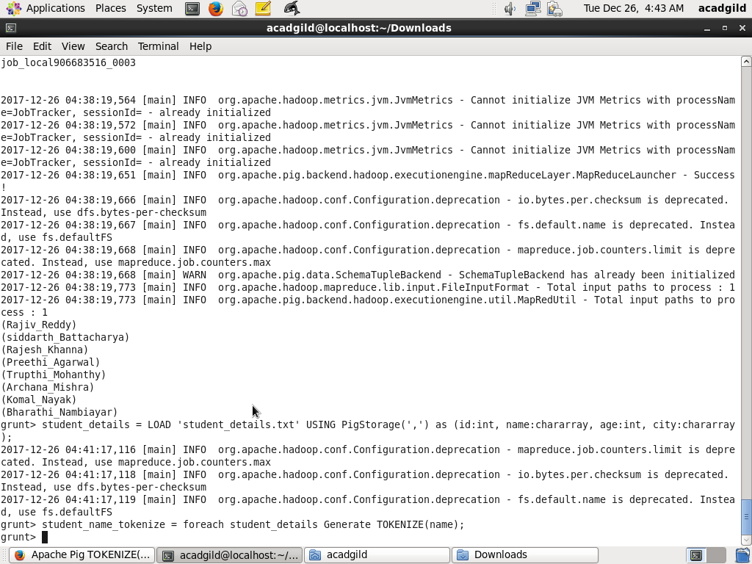

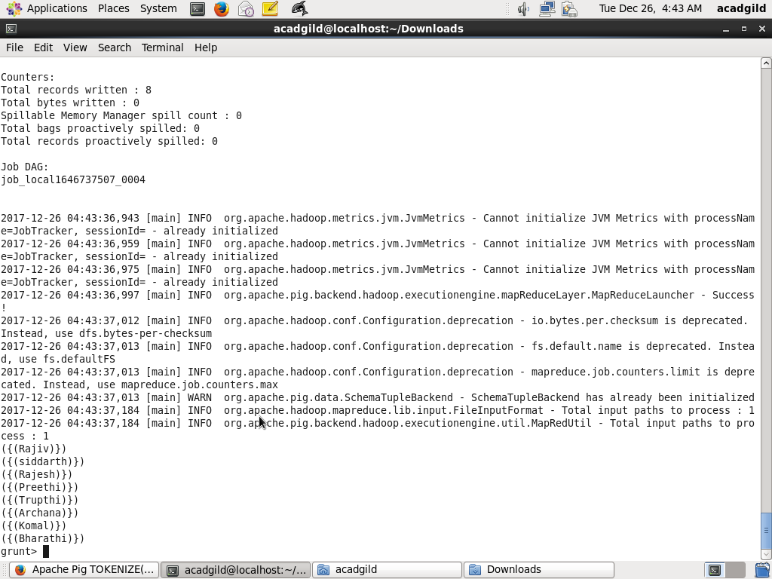

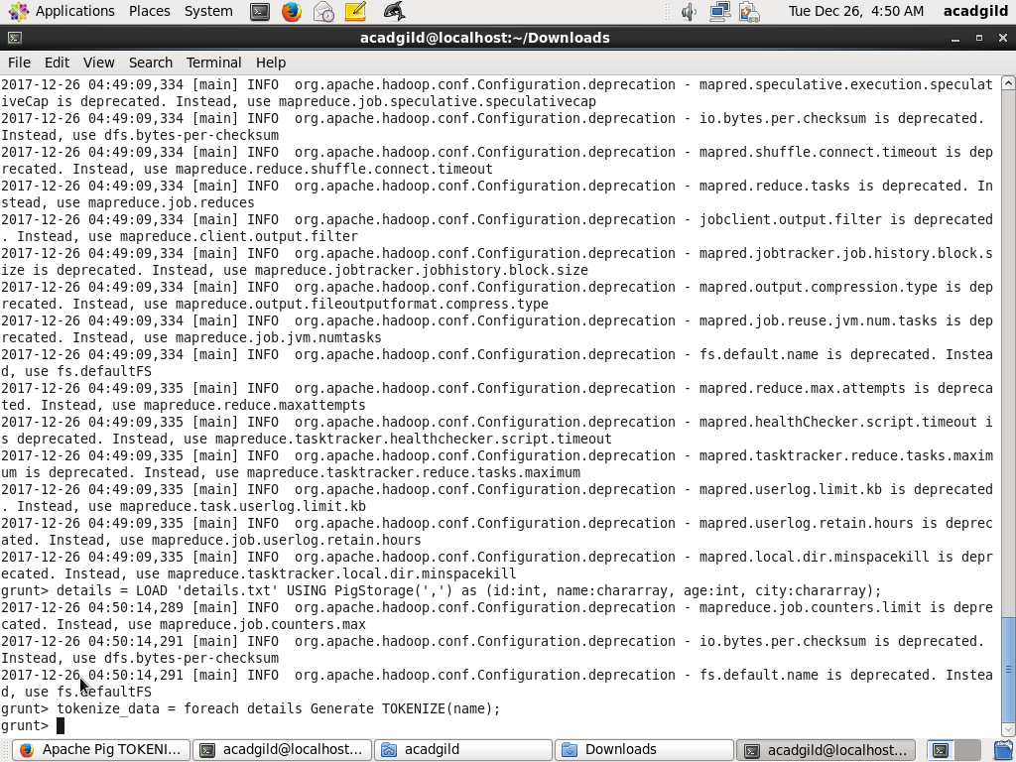

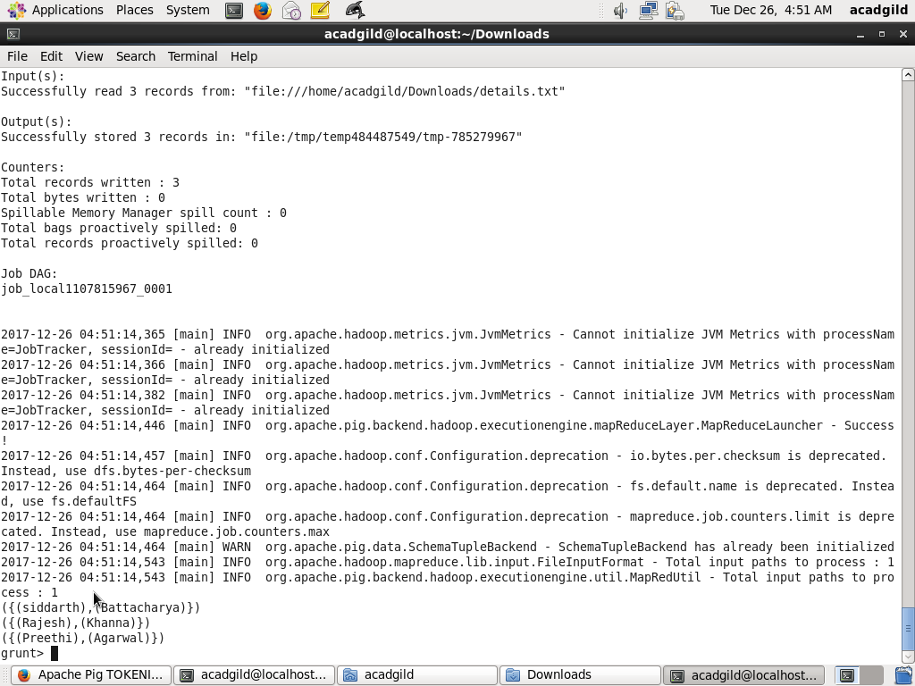

**3) Sum**

the **SUM()** function of Pig Latin to get the total of the numeric values of a column in a single-column bag. While computing the total, the **SUM()** function ignores the NULL values.

## Syntax

Given below is the syntax of the **SUM()** function.

grunt> SUM(expression)

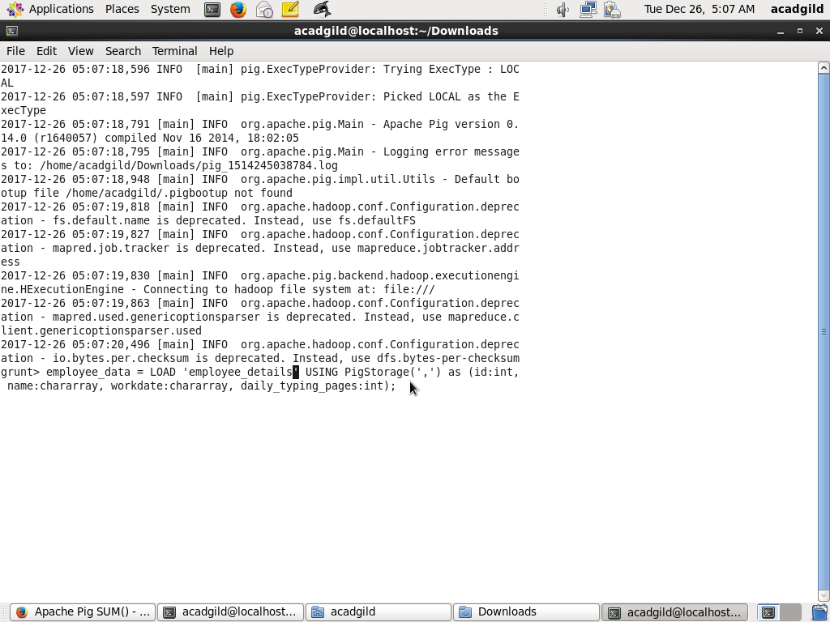

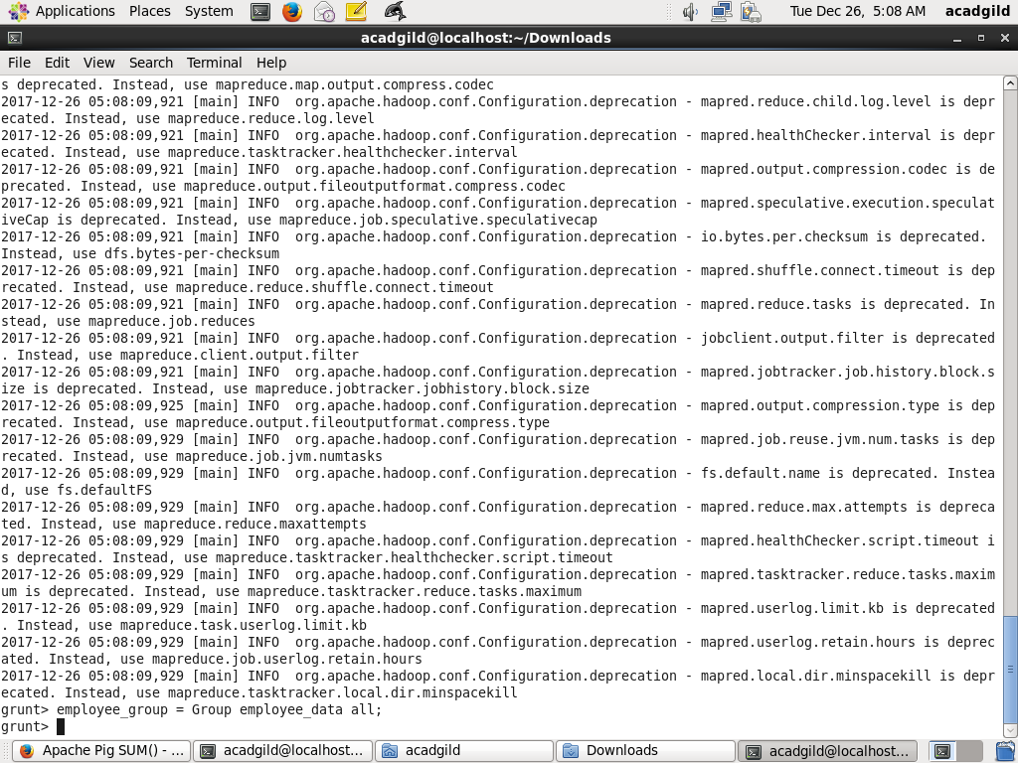

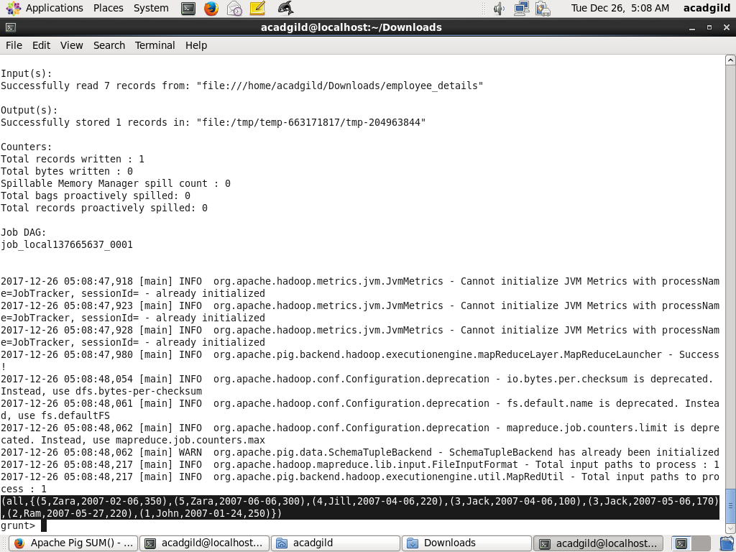

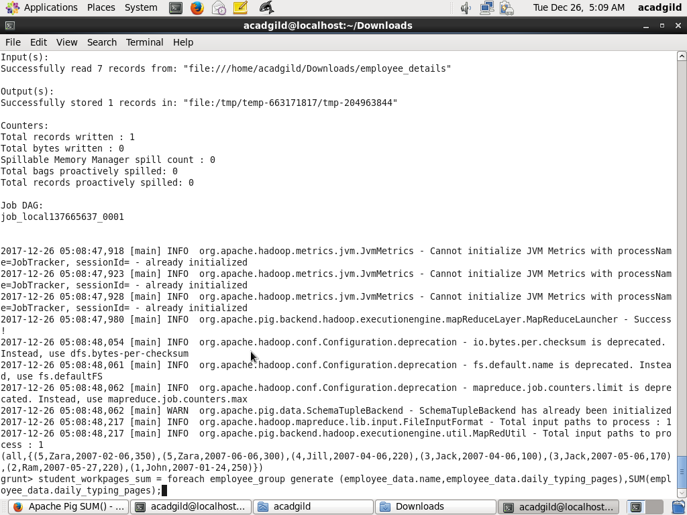

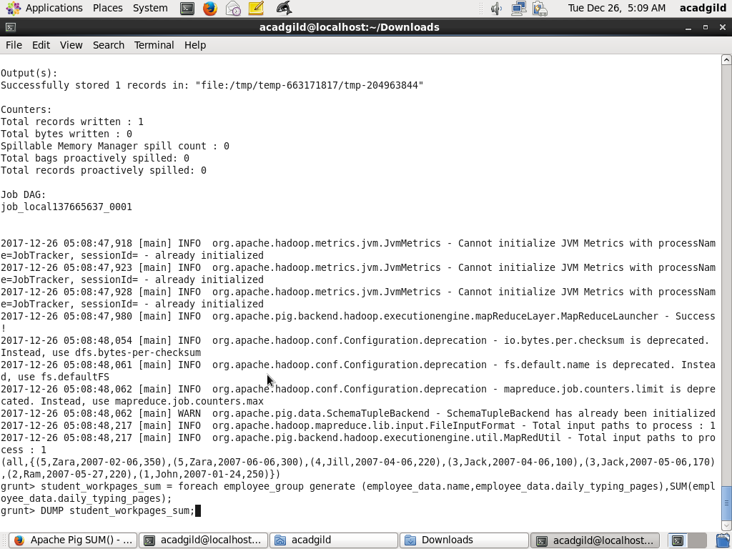

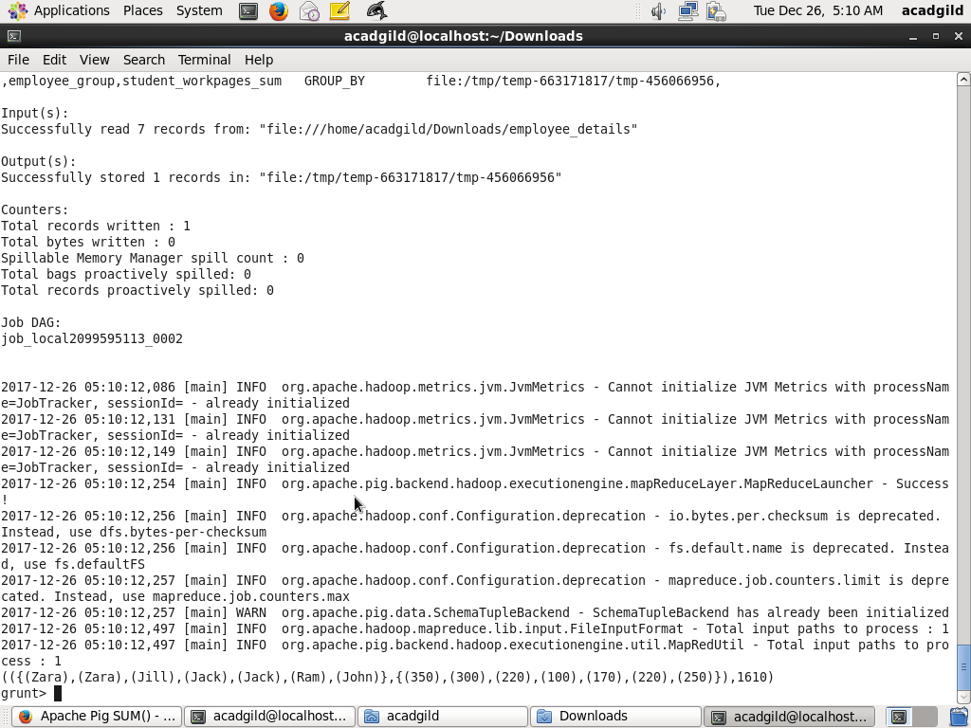

**4) Min**

The **MIN()** function of Pig Latin is used to get the minimum (lowest) value (numeric or chararray) for a certain column in a single-column bag. While calculating the minimum value, the **MIN()** function ignores the NULL values.

## Syntax

Given below is the syntax of the **MIN()** function.

grunt> MIN(expression)

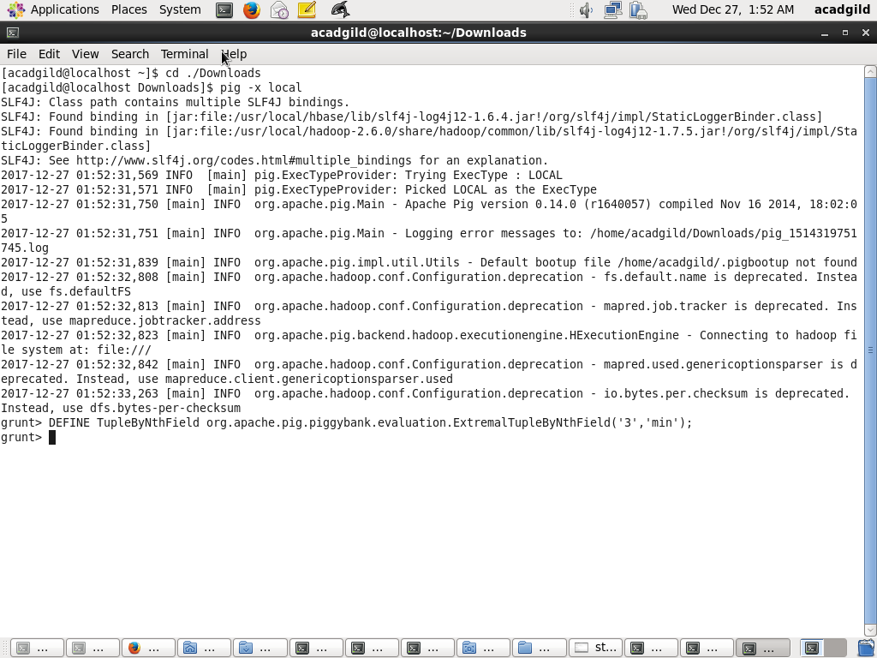

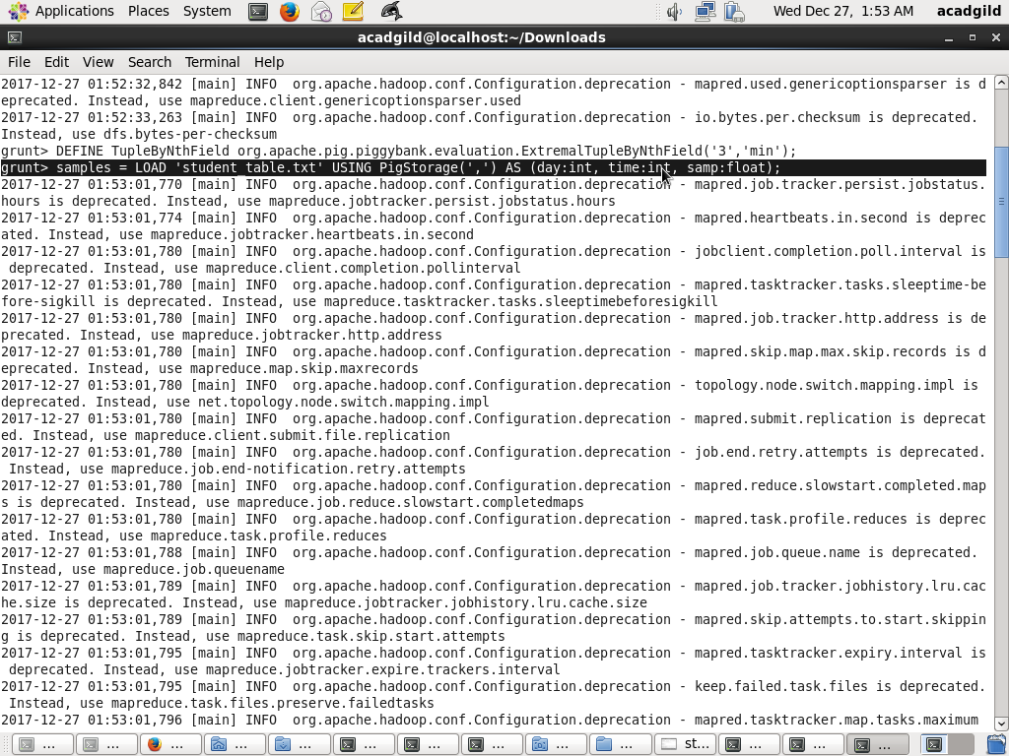

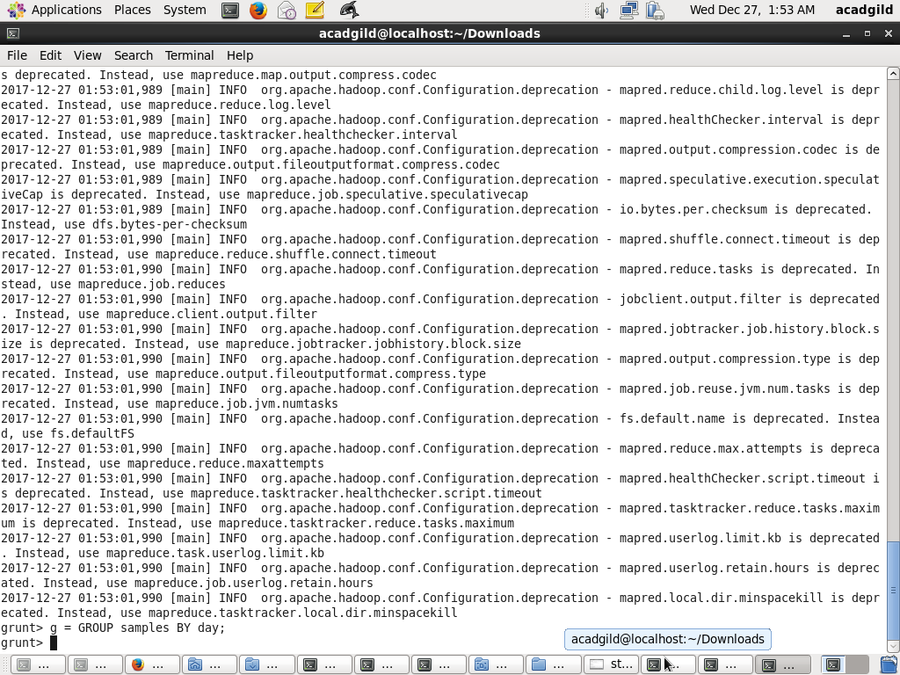

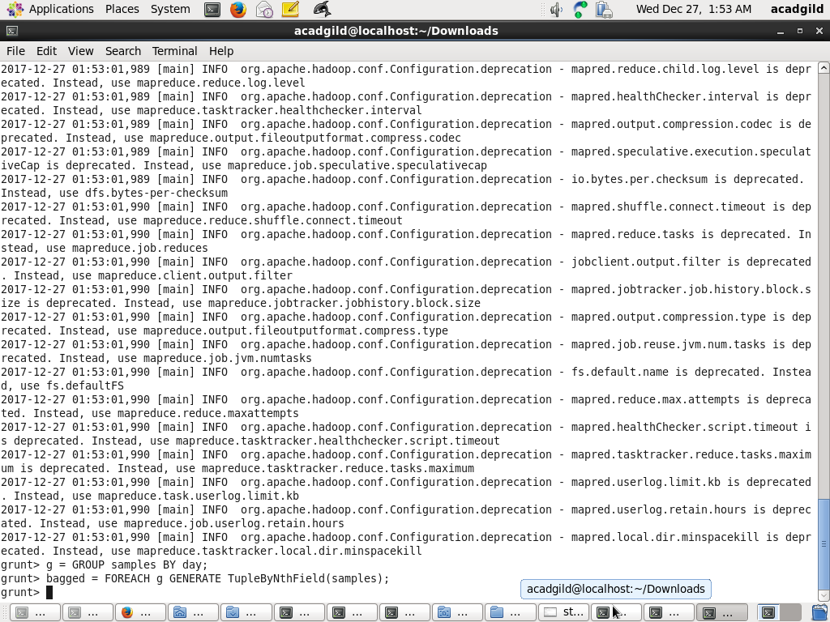

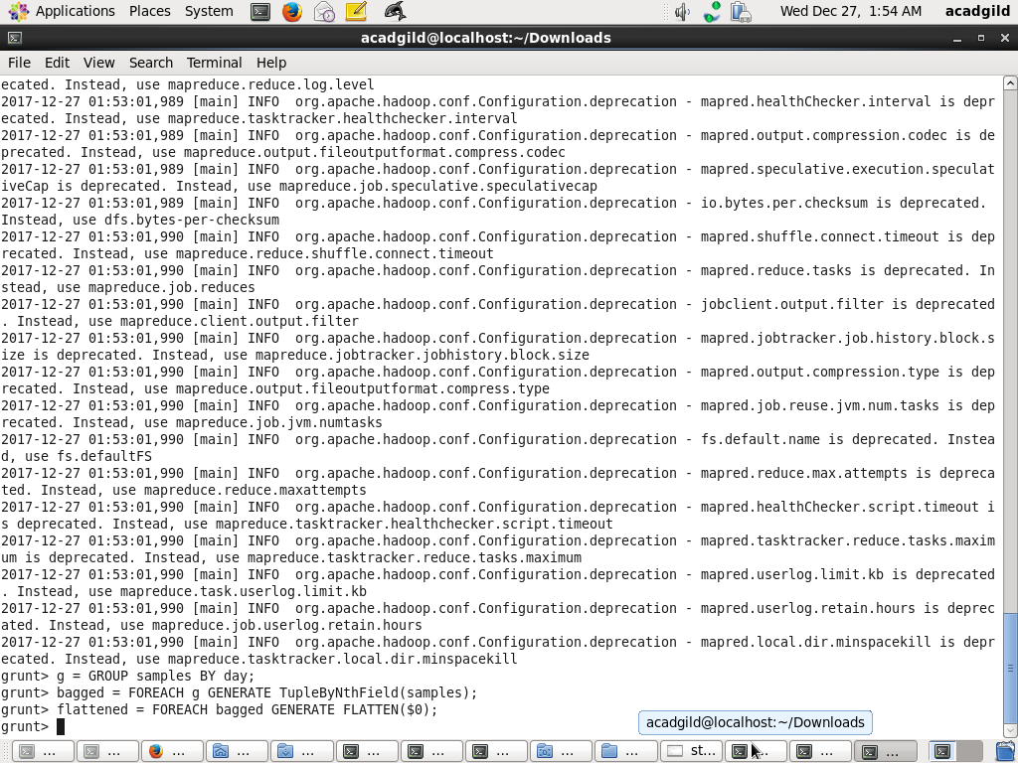

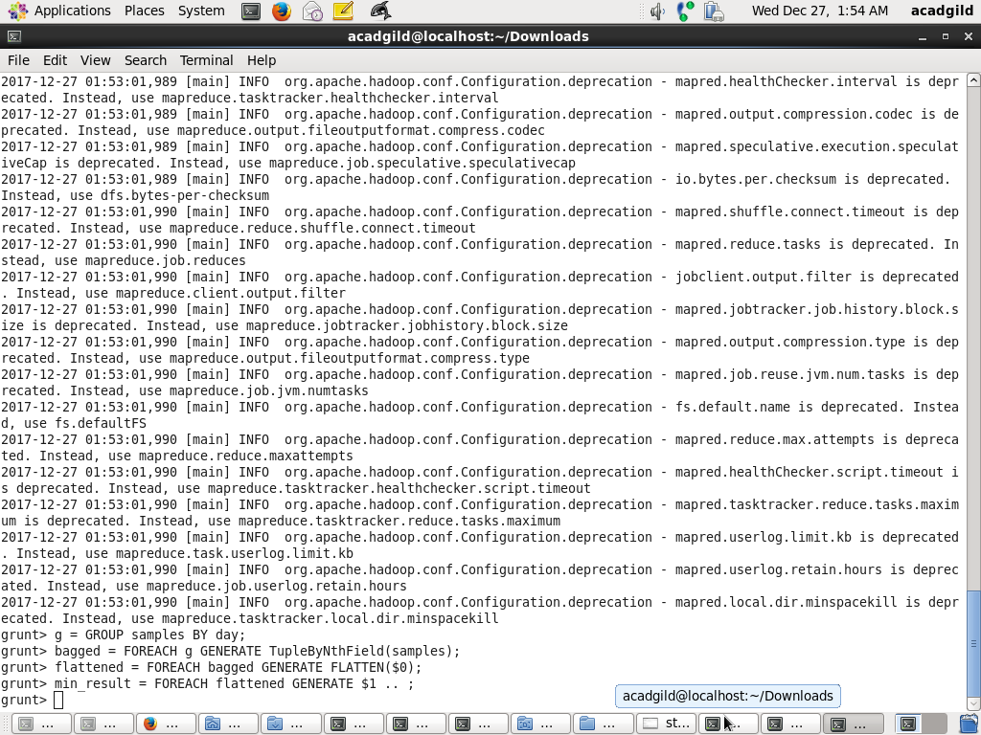

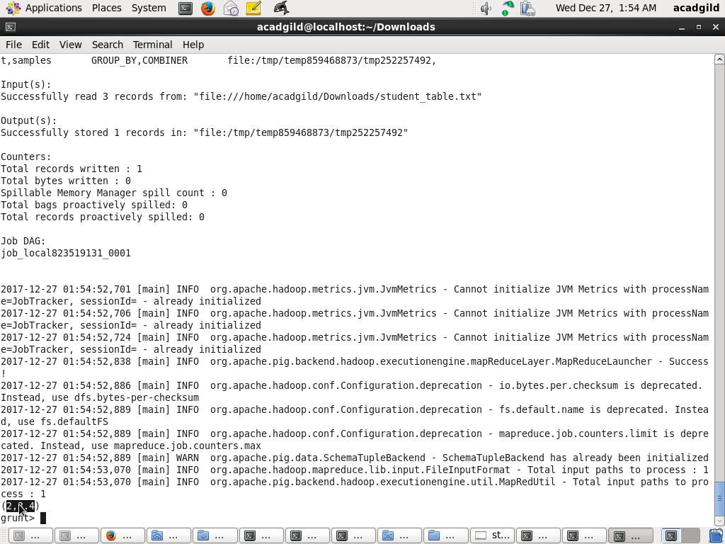

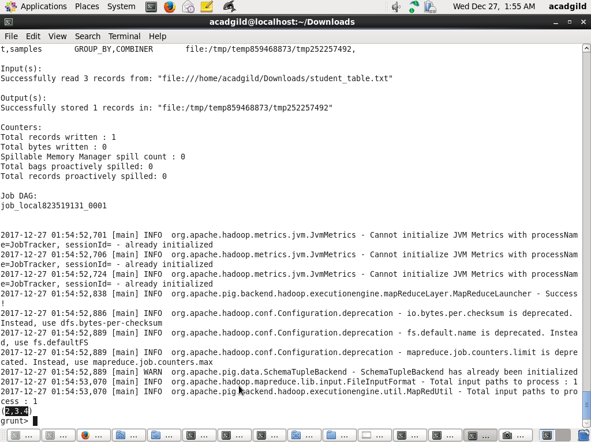

**5) Max**

**MAX()** function is used to calculate the highest value for a column (numeric values or chararrays) in a single-column bag. While calculating the maximum value, the **Max()** function ignores the NULL values.

## Syntax

Given below is the syntax of the **Max()** function.

grunt> Max(expression)

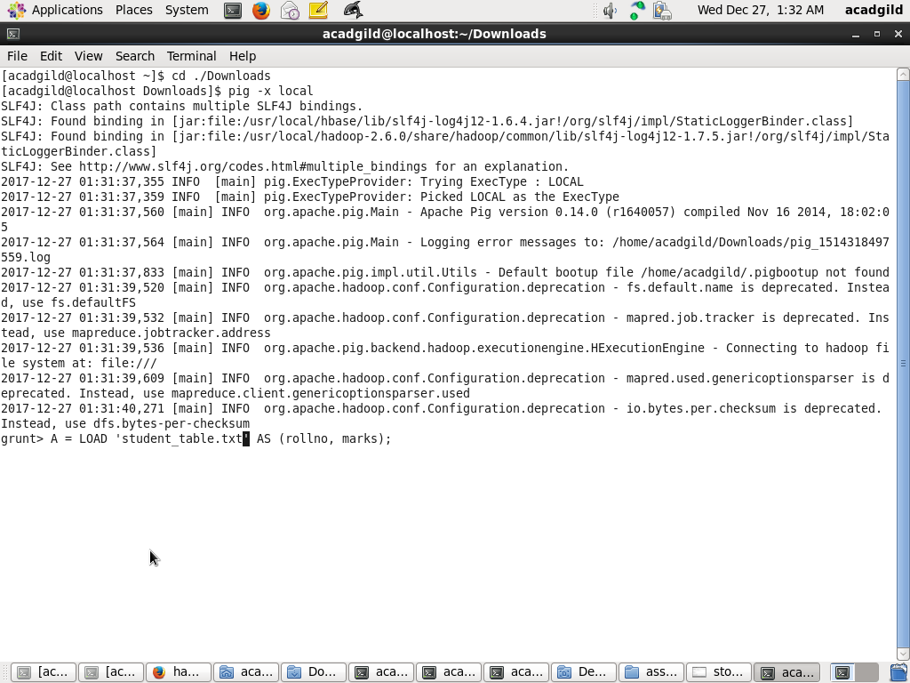

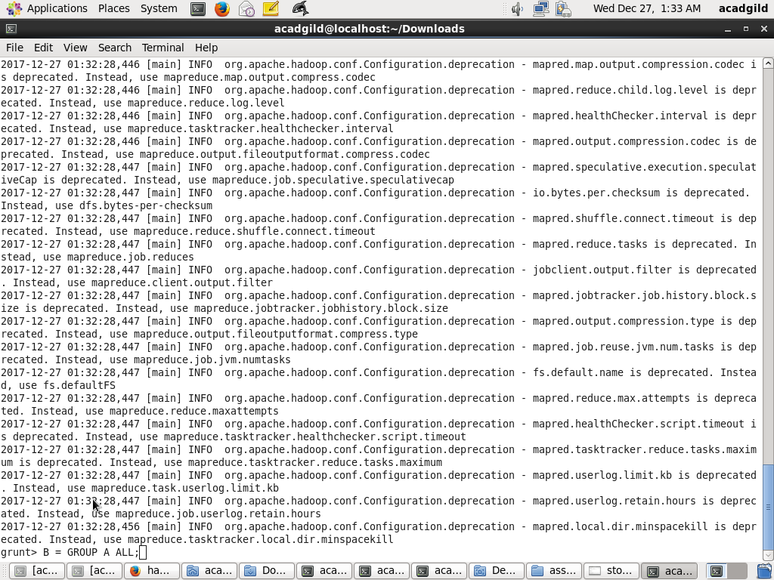

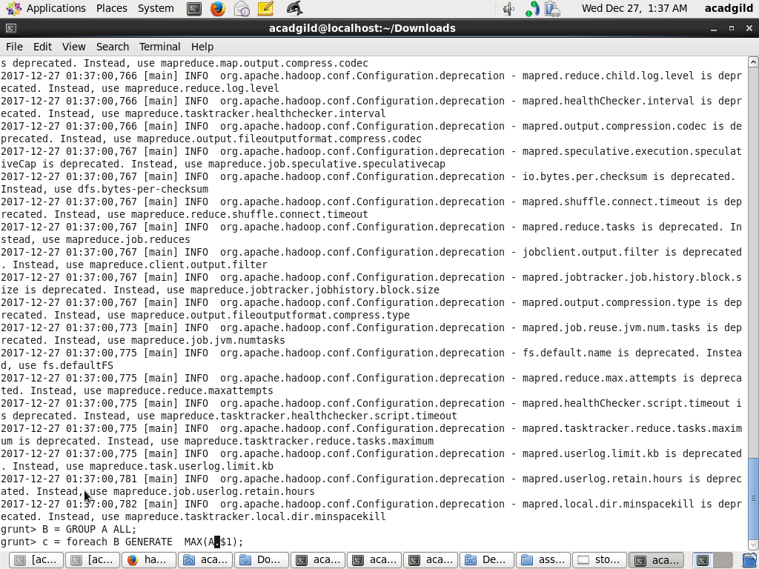

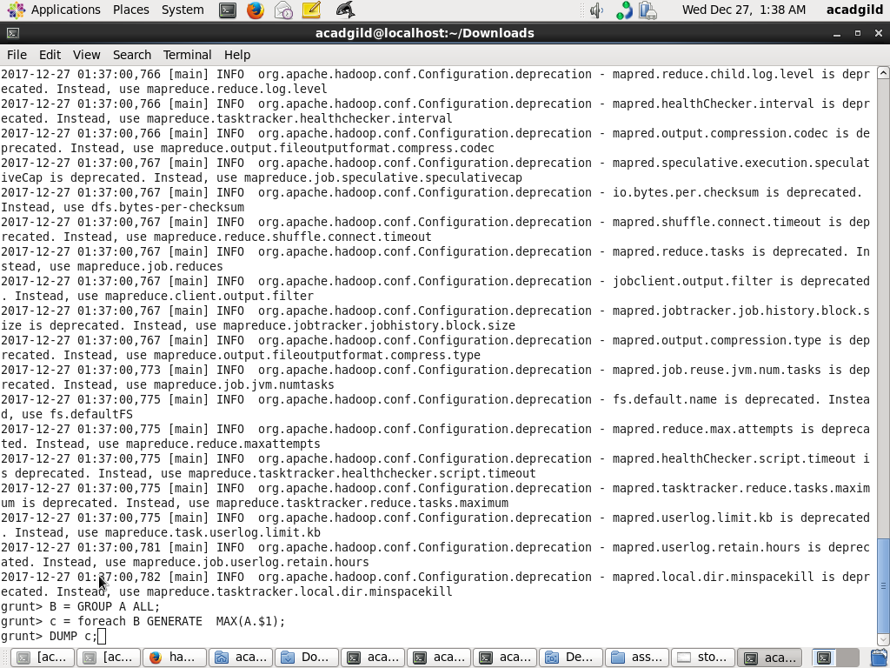

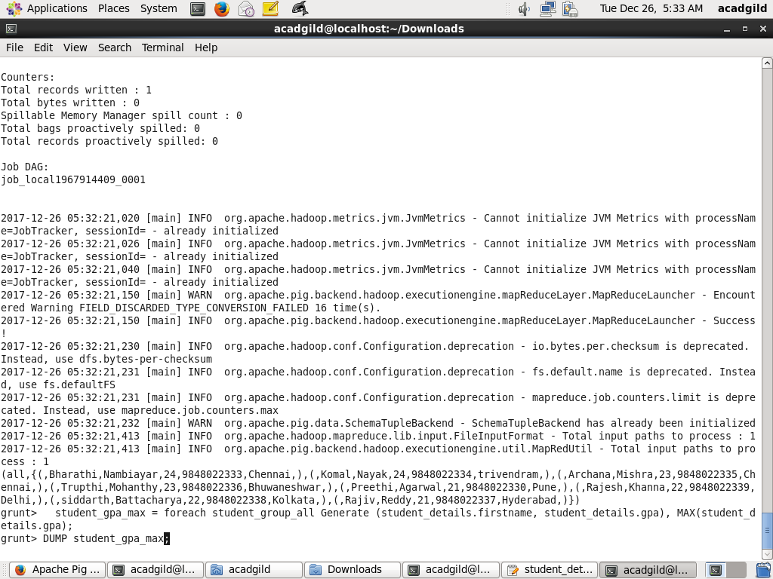

**6) Limit**

The **LIMIT** operator is used to get a limited number of tuples from a relation.

## Syntax

Given below is the syntax of the **LIMIT** operator.

grunt> Result = LIMIT Relation_name required number of tuples;

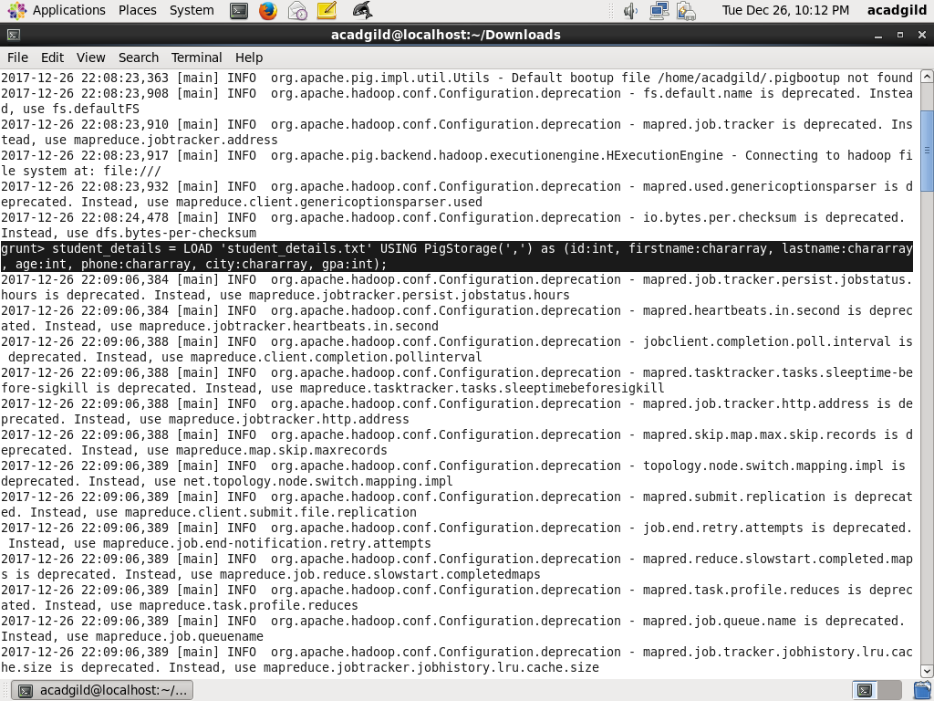

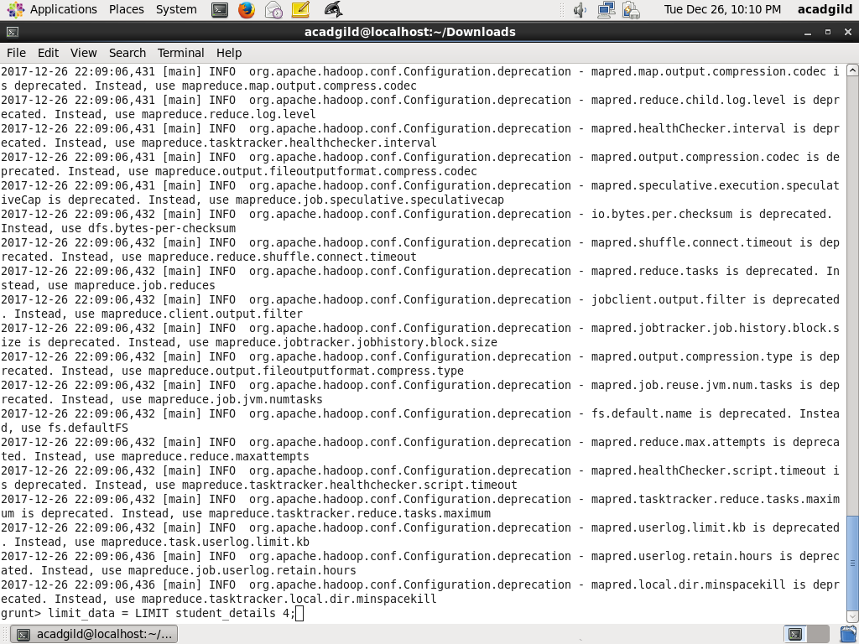

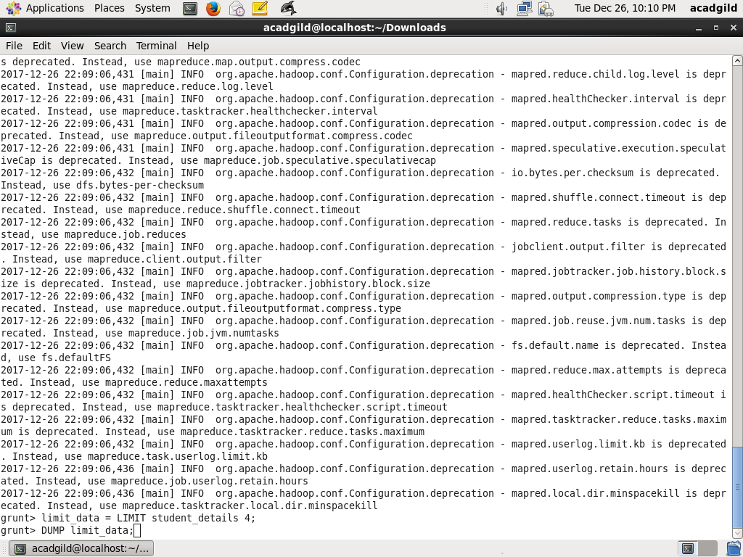

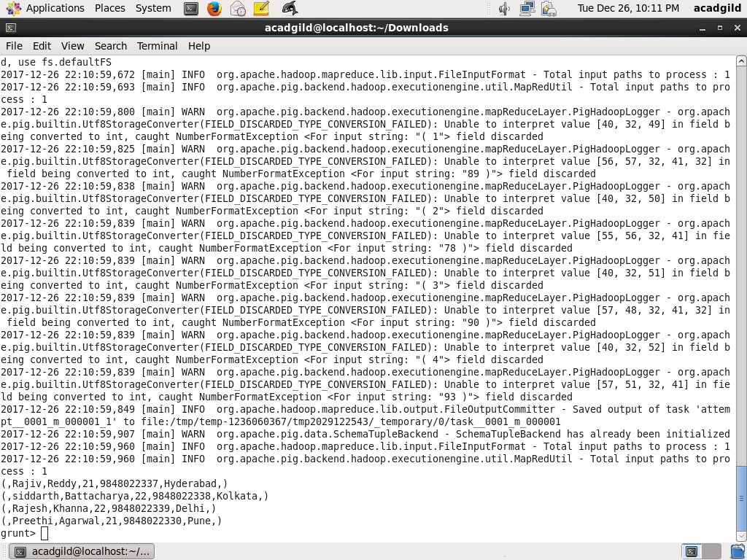

**7) Store**

## Syntax

Given below is the syntax of the Store statement.

STORE Relation_name INTO ' required_directory_path ' [USING function];

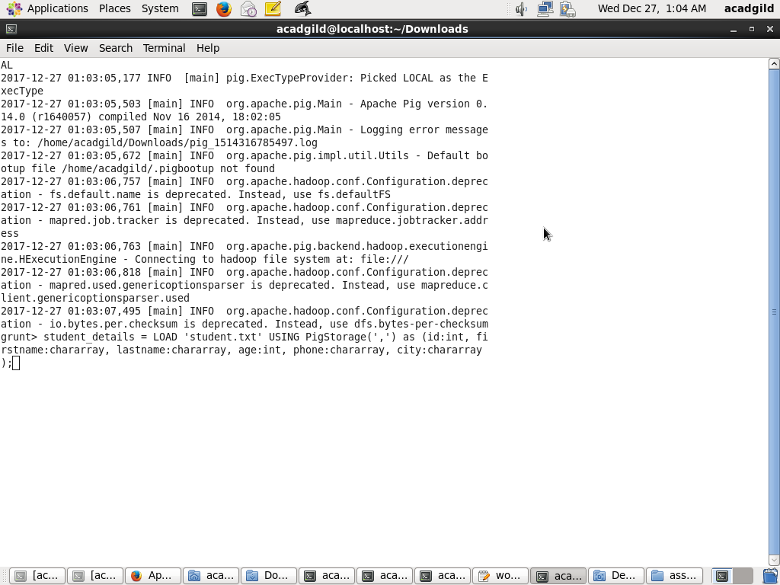

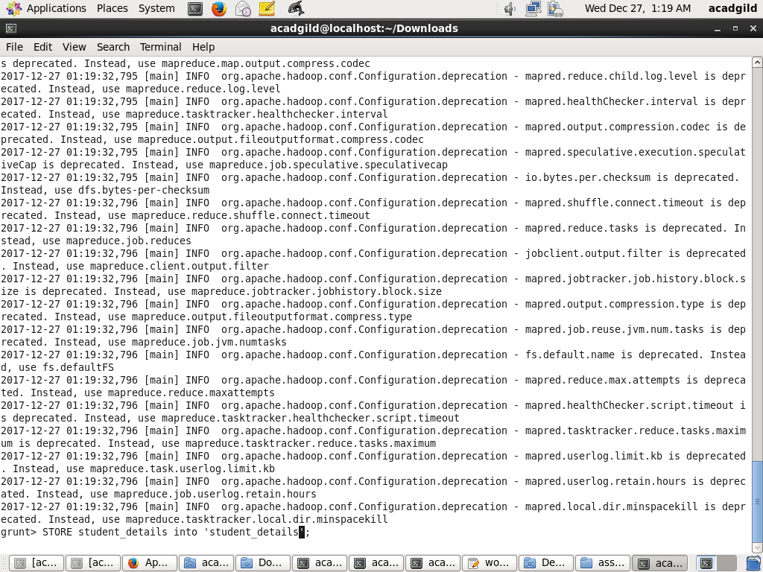

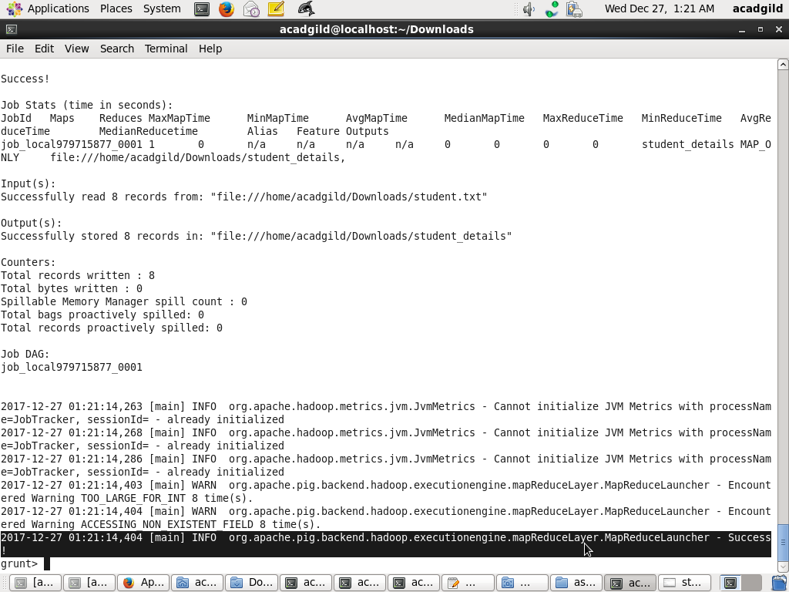

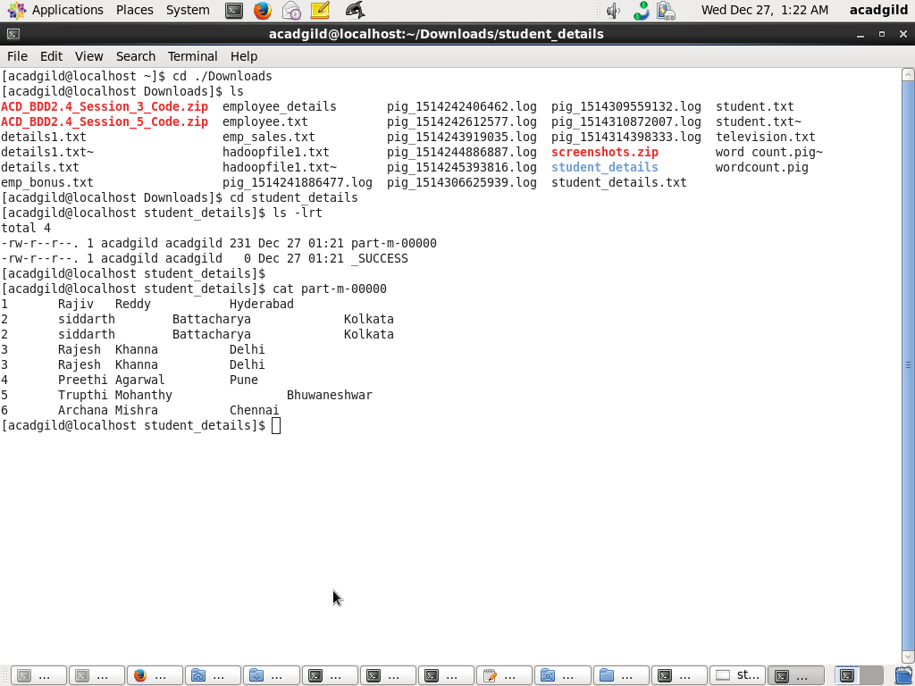

**8) Distinct**

The **DISTINCT** operator is used to remove redundant (duplicate) tuples from a relation.

## Syntax

Given below is the syntax of the **DISTINCT** operator.

grunt> Relation_name2 = DISTINCT Relatin_name1;

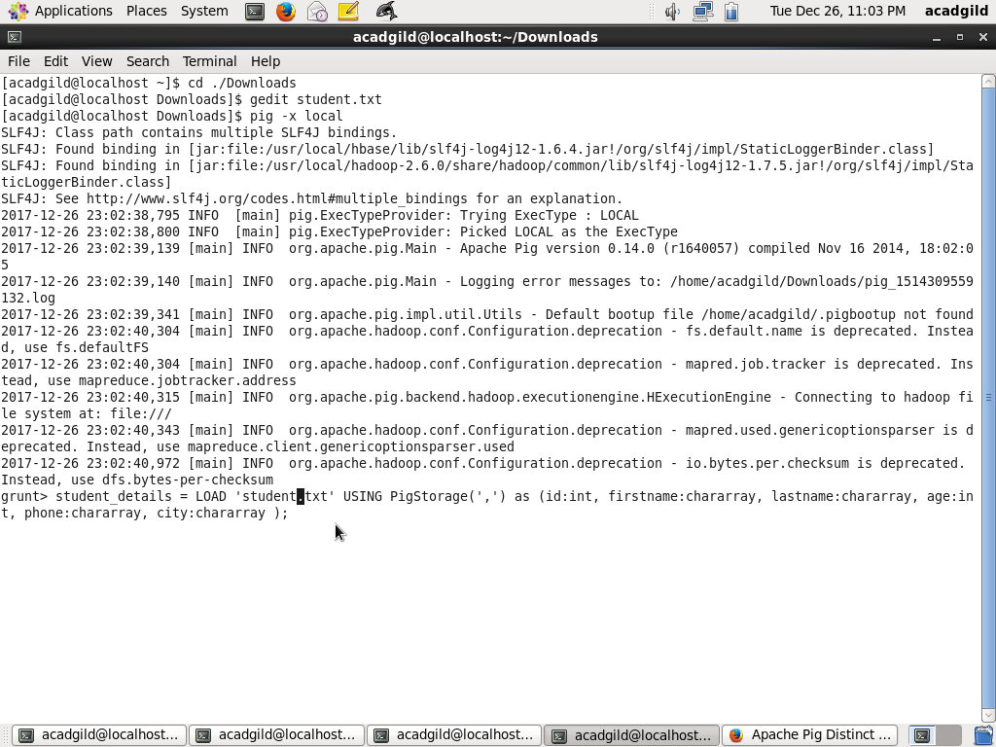

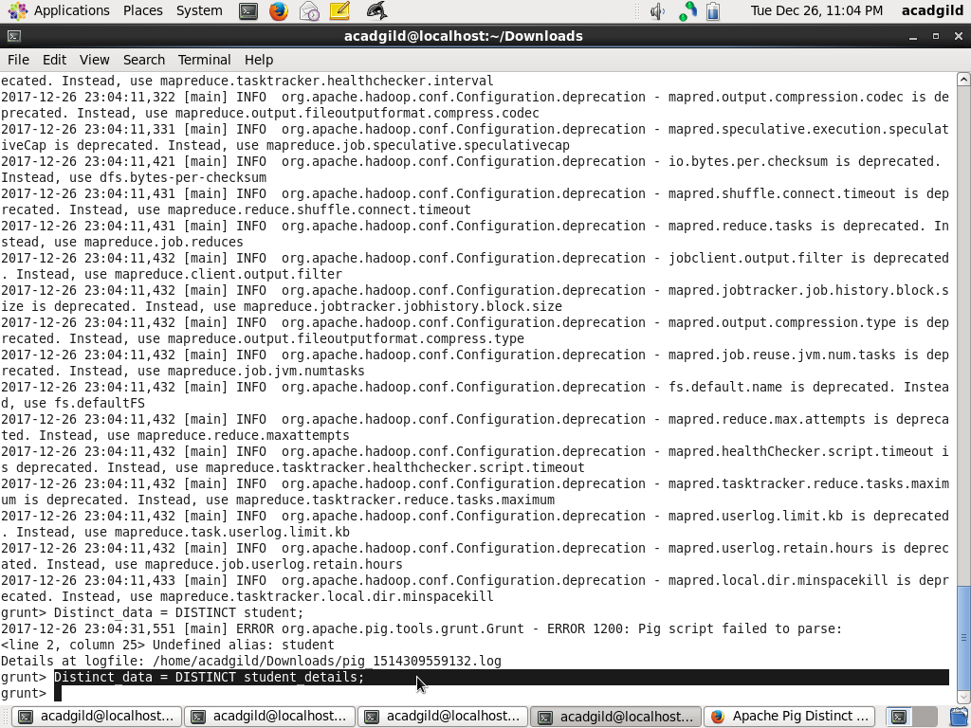

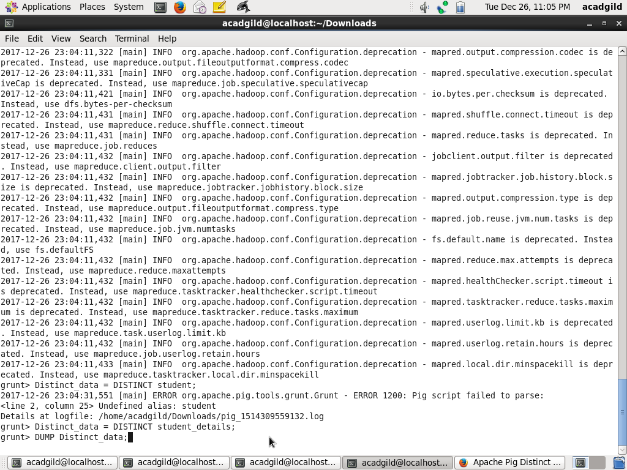

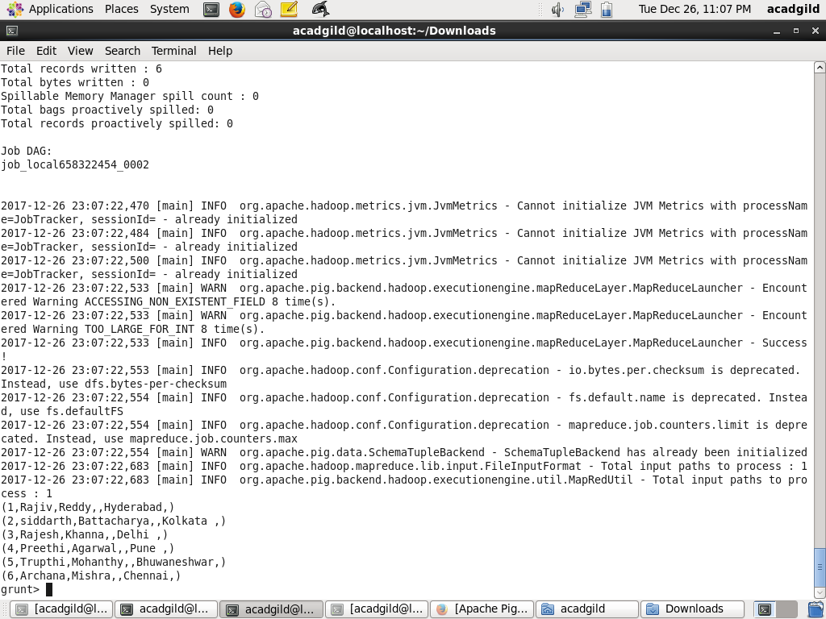

**9) Flatten**

The FLATTEN operator looks like a UDF syntactically, but it is actually an operator that changes the structure of tuples and bags in a way that a UDF cannot. Flatten un-nests tuples as well as bags. The idea is the same, but the operation and result is different for each type of structure.

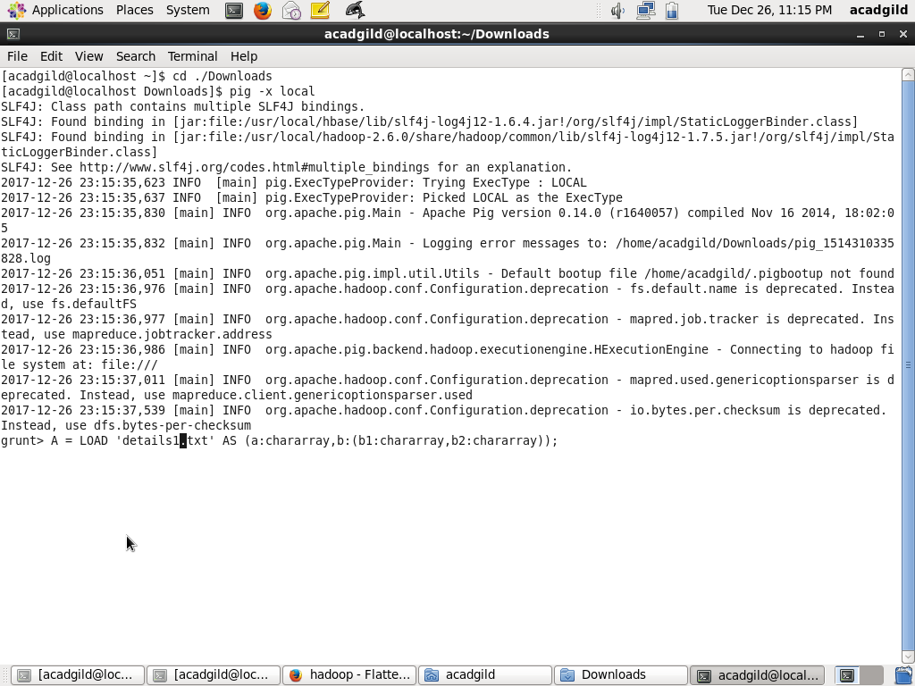

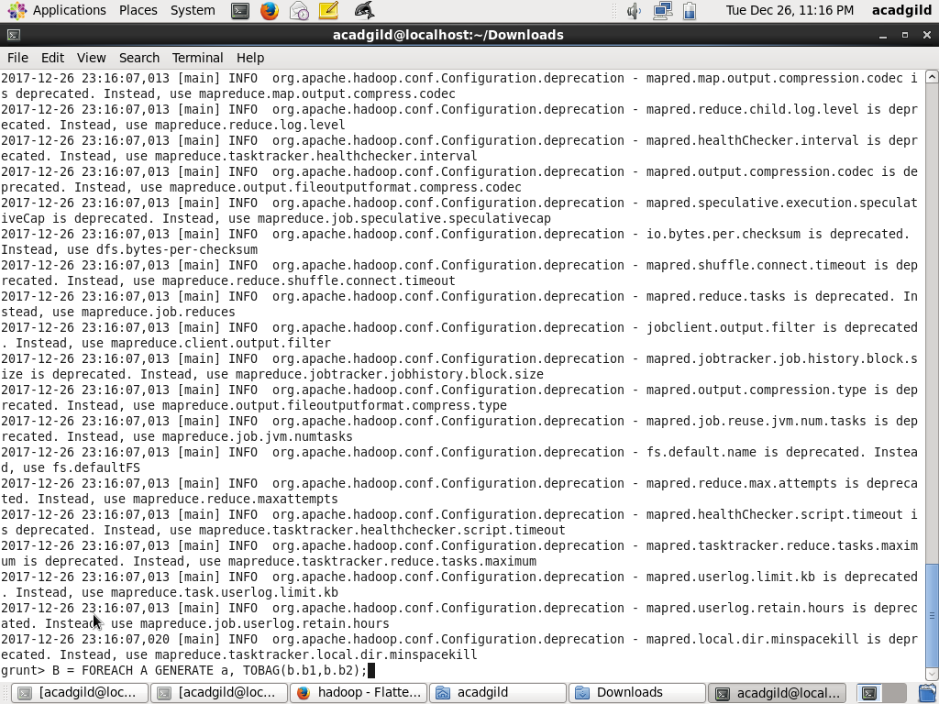

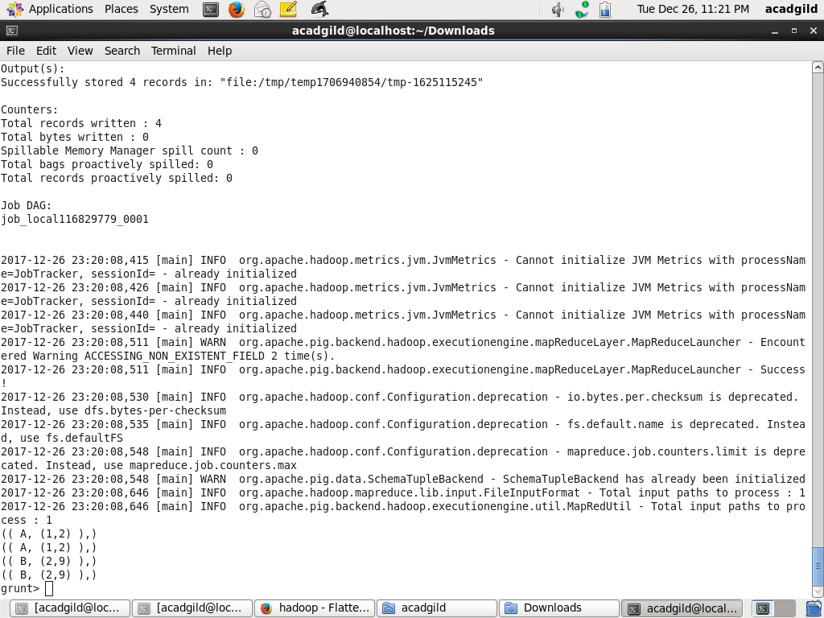

10) **IsEmpty**

The **IsEmpty()** function of Pig Latin is used to check if a bag or map is empty.

## Syntax

Given below is the syntax of the **IsEmpty()** function.

grunt> IsEmpty(expression)

